
*Please download this document and view it locally*

Getting Started with OMV
Addendum B:

Installing OMV5
On a Raspberry PI




January 5th, 2019 – (rev 1.3)

Table of Contents
- Introduction 3
About this Guide 3
- Supported Devices 3
Not Supported 3
- Prerequisites 4
- Working With The Image File 5
Verify the Archive file 5
Decompress the Image 6
Format and Test Flash Media 7
Flashing Raspbian Buster Lite onto an SD-card 10
- Enabling Raspbian's SSH Server for Remote Access 11
- The First Boot 13
- Raspbian - First Time Logon 14
Raspbian Updates and Upgrades 15
- Install OMV 16
- First Time GUI Logon 17
Configuring the Network 17
- Finishing Up: 18

Introduction
Installing OMV5 on Raspbian Lite, using a scripted install, is a relatively easy task. This document is a guide for that purpose.

About this Guide
The purpose and intent of this guide is to provide a walk-through to get Raspberry Pi users (R-PI) up and running as quickly and as easily as possible. This guide assumes that users have a working Windows Client for installing and executing the needed utilities. It is also assumed that Mac and Linux desktop users will be able to find, install, and use utilities equivalent to those called out in Prerequisites.
- This guide contains links to external sources of information and software. It's best used on an Internet connected PC.
- This is a community document and a work in progress. Input and feedback are welcome and can be sent to: omvguide@gmail.com

_________________________________________________

Supported Devices

OMV5 will install on R-PI models 2B and higher. In practical terms, the performance of the model 2B is marginal.

Not Supported
R-PI models earlier than the 2B and the R-PI Zero have not been tested and are not supported. They are far too slow to run a NAS application. Please do not post on OMV's forum, expecting support for these models.

(Continued)

Prerequisites
This installation process requires a wired Ethernet connection and Internet access.
Typically, all that is needed to begin the installation is an Ethernet cable, an R-PI, a power supply sufficient for the R-PI model being used, and one SD-card (two are preferred for backup).

To get started, a few utilities are needed to check, expand, and work with the Raspbian image.

- Raspbian images are compressed with a .zip extension. Users will need a utility like 7-Zip to decompress the image. 7-Zip is installable on a Windows client.
- To check the decompressed image, an MD5 – SHA Checksum utility is needed. This utility is portable, meaning it's not necessary to install it, but it may require support files. Simply run the executable.
- SDformatter is a utility for formatting SD-cards, that does a trim operation on flash media to clear remnants of old files. SDformatter is installable on a Windows client.
- h2testw_1.4 is a flash media test program. With a freshly formatted SD-card or USB thumbdrive, it writes files with known content and verifies that content in a read operation, detecting errors in the process. h2testw_1.4 downloads as a zip file. By right clicking on the zip file, and using “Extract All”, 7-Zip will expand the zip file to a folder named h2testw_1.4 The executable inside this folder is a portable application. Run the executable.
- To burn a Raspbian image to an SD-card, Etcher is recommended. (It burns the image and verifies it in one process.) Etcher is a portable app. Run the executable.
- PuTTY is an SSH client that will allow users to connect to their SBC, from a Windows client, and get on the command line. PuTTY is installable.
- While 8GB is the minimum and will work fine, a 16GB card will provide longer life in the role of a boot drive. Users are encouraged to get two SD-cards. One is for the installation and the second is for backing up the OS installation when configuration is complete.
For the best experience, use only quality new SD-cards such as Samsung or SanDisk, that are rated A1, Class 10.

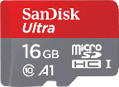
- **Important**
When selecting a Raspbian Image, for best possible compatibility with OMV5, don't use an image with a desktop.
On the Raspbian download page, scroll down to bottom, select and download the Raspbian Buster Lite image.

Per the download page, the SHA-256 hash for this version of Buster Lite was: 9e5cf24ce483bb96e7736ea75ca422e3560e7b455eee63dd28f66fa1825db70e
(** The hash number will change with the image, as images are updated. **) Make a note of the hash number found, or bookmark the download web page for reference. This will be used later.

Working With The Image File

Verify the Archive file
After downloading the Buster Lite archive, MD5 and SHA hashes check for file corruption that may have occurred during the download.
The Raspberry PI project provides a SHA-256 hash check number for the downloaded Zip archive file.
**Beginners Note**
DO NOT SKIP THIS STEP. The chance of corruption is highest when downloading and it's pointless to build a server with flawed software. Even the slightest amount of corruption may ruin your installation and the effects may not be noticed until well after your server is built and in use. Headaches can be avoided by checking the zip archive.
__________________________________________________

Verify the downloaded Zip file with the MD5 & SHA checksum utility.
(Note that it's possible to “drag and drop” the file name into the utility, on the File line. Otherwise, use the Browse button and navigate to the compressed image file.)

With the previously noted down SHA-256 hash, or by referencing the Raspbian Web page, compare the utility's result with the SHA-256 hash provided on the download page.
In this specific case it's: 9e5cf24ce483bb96e7736ea75ca422e3560e7b455eee63dd28f66fa1825db70e
With a SHA-256 match, the downloaded file is verified.

Decompress the Image
Raspbian images are compressed and will need to be extracted with 7-Zip. (The following process assumes 7-Zip has been installed.) Highlight the compressed file, right click the mouse, and make the menu selections shown below.
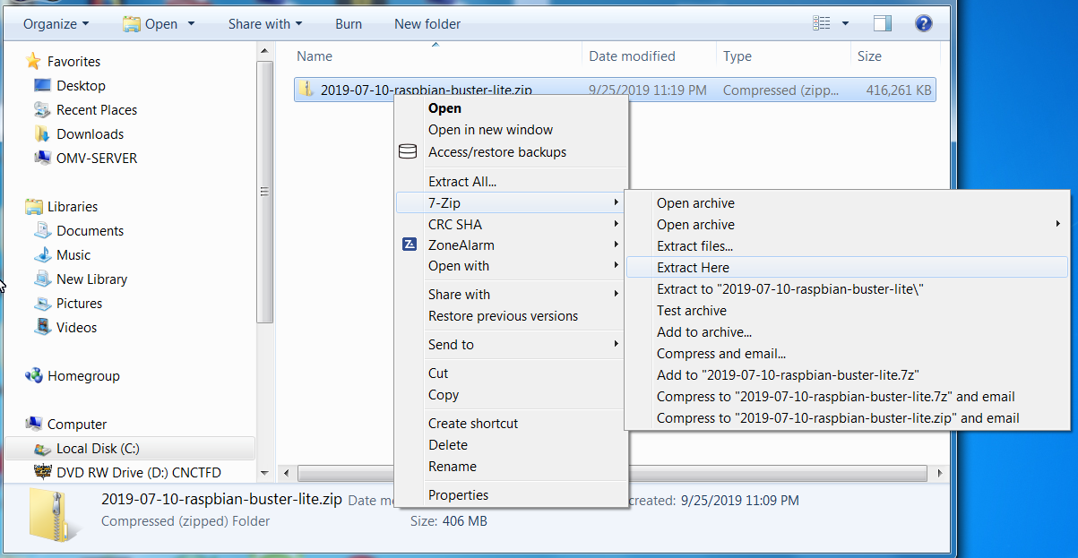

The result of the above action is the extraction of an uncompressed folder, with the image file inside. Open that folder. The image file's extension is .img

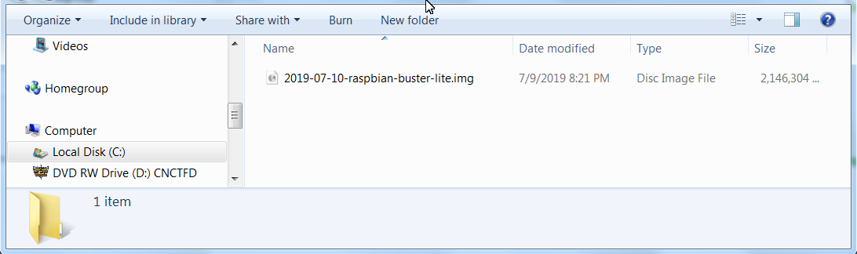

Format and Test Flash Media
Using SDFormatter, do a clean format on the new SD-card:
(Note that SDFormatter does a trim operation on the card which cleans up remnants of deleted or previously existing files.)
In most cases, SDFormatter will detect the SD-card or thumb-drive. A volume label is not necessary, at this point, and the default options are fine.
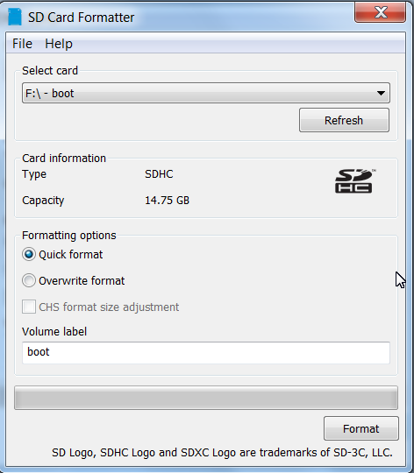

After the SD-card format is completed, open h2testw and select your language.
Then, click on Select target
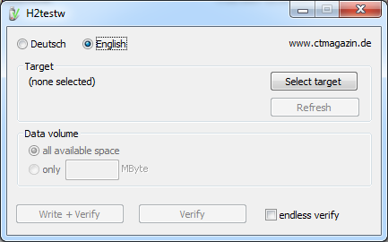

Under Computer, select the flash media previously formatted.

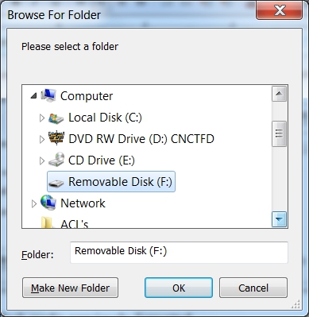
Select Write+Verify. (DO NOT check the endless verify box)
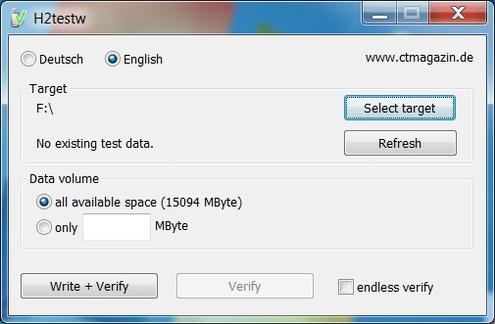
A dialog similar to the following may pop up, showing a 1MB difference. Ignore it and click on OK.
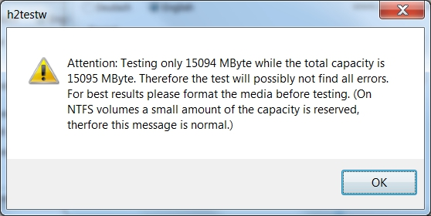
“Without errors” is the desired outcome. If the media tests with errors or is much smaller than is indicated by the SD-card's labeled size, don't use it.

After H2testw verifies the SD-card; do one more clean format, using SDFormatter, before flashing the card. While optional, at this point, a volume label could be applied.

Flashing Raspbian Buster Lite onto an SD-card

Start Etcher:
Etcher, in most cases, will auto detect the SD-card or a USB thumb-drive. Click on “Select Image” and navigate to the decompressed Raspbian image. Then click on Flash!
- A windows confirmation dialog may pop up. (Click on OK.)
- Etcher will write the image, then verify it in one operation.

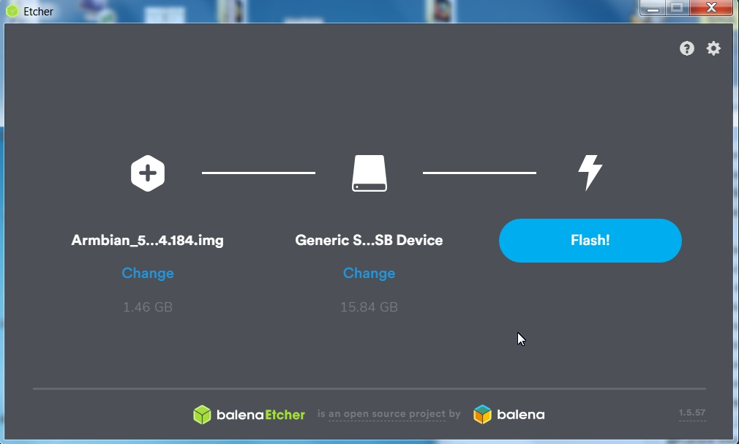

A “Success” flag will pop up when the job is finished and the Etcher window will display “Flash Another?”.
The flash operation is complete. (For the moment, leave the SD-card connected to the PC.)

(Continued)

Enabling Raspbian's SSH Server for Remote Access
Raspbian is designed to have it's configuration finalized with a monitor and keyboard attached. There's no need for a monitor and keyboard to support an OMV installation. OMV was designed, from the ground up, to run as a headless server.
For the sake of convenience, Raspbian can be configured to enable it's SSH server on first boot, so the server can be accessed remotely with PuTTY. The following will enable SSH access.

**To insure the file system on the Raspbian flashed card is recognized, unplug the SD-card for a few moments and plug it back into the PC used to flash the SD-Card.**
- Open a file manager window, displaying the file contents of the of the SD-card.
- Right click in the files side (right window) and select, New, and Text Document.
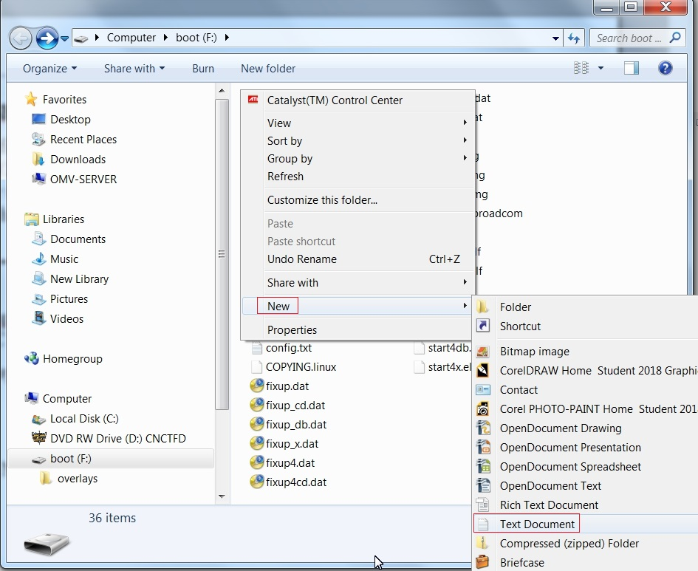

A file is created. Name the file ssh with no extension.

Confirm, as shown, that the file SSH has no extension. (This will mean removing .txt from the file name.)
The following warning may pop up, regarding a file without an extension.
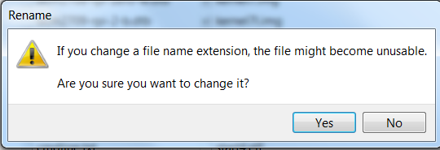
Ignore it and select “Yes”.

The First Boot
**At this point, to connect to the SBC with PuTTY and to install OMV in a later process, a wired Ethernet connection is required.**

- Insert the SD-card, with the Raspbian image, into the R-PI and apply power.
- Wait 3 to 5 minutes.
The IP address to use for logging into the console is available from your DHCP server. In most cases, the DHCP server will be running on the users LAN router. Log into your router and look for the IP address associated with your R-PI.
(The following is an example.)
With the IP address noted, proceed to First Time Login.

**If there's a problem with obtaining a DHCP assigned IP address:**
  - In the event that an IP address is not issued to your SBC, check the wired Ethernet connection and reboot the device. This will mean unplugging and plugging the power supply back in.
Allow time for boot up (5 minutes or so) and check the DHCP server again.
  - If an address is not issued, or if the user doesn't know how to find the Raspberry Pi's IP address on their DHCP server:
Connect a monitor and a USB keyboard to watch the boot process until it completes. If the IP address is not displayed at the end of the boot cycle, login with the user pi using the password raspberry.
Once logged in, type ip add on the command line. Note the IP address of the Ethernet interface, in the output, and proceed to First Time Login.
(To be able to utilize Copy + Paste; working with the R-PI using SSH as detailed in First Time Login, is highly recommended.)

Raspbian - First Time Logon

Open PuTTY and type in the IP address as previously found.

A PuTTY Security Alert will pop up in a first time connection.
This is normal. Ignore it and select Yes.
When the SSH window opens:
Login as: pi The Raspbian default password is: raspberry
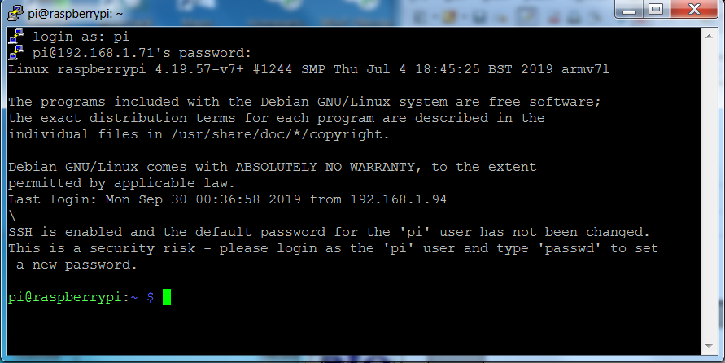
After logging in with the default password, it's strongly recommended that the password for the pi user be changed.
On the command line, type;
passwd
Re-enter the current password raspberry, then follow the prompts to enter and confirm a new password for the pi user password. (Remember this password.)

When the password change is complete, one more change is needed to insure the pi user can log in, more than once, VIA SSH. The following command adds the user pi to the ssh user group, enabling future SSH sessions.
On the command line type or copy and paste in the following command;
sudo adduser pi ssh

Raspbian Updates and Upgrades
Before installing OMV, update and upgrade Raspbian using the following two commands, executed one at at time:
sudo apt-get update
sudo apt-get upgrade (If the upgrade halts, with a prompt to read, press q to “quit” and the upgrade will proceed.)
When updates and upgrades are complete, type sudo reboot on the command line.
PuTTY will disconnect – this is expected. Wait 3 to 5 minutes and reopen a new PuTTY SSH window and log in.

Install OMV
Installing OMV on Raspberry's is very easy, thanks to Ryecoaaron for providing a comprehensive installation script that's executed from a single line.
Copy the following line complete (Ctrl+C) and paste it into PuTTY's SSH window, with a right mouse click. Then hit Enter.

wget -O - https://github.com/OpenMediaVault-Plugin-Developers/installScript/raw/master/install | sudo bash

Once the script is running, click out of the SSH window so the script will not be interrupted. Depending on several factors, running this script will take approximately 30 minutes.
When the script is complete, the device command prompt will return:
pi@raspberry:~$

Type the following command into the PuTTY/SSH window:
sudo reboot

(Continued)

First Time GUI Logon
After 3 to 5 minutes, OMV can be logged into using the same IP address that was used for the SSH client, entered in a web browser address bar. The web GUI user is admin and the default password is openmediavault

Configuring the Network
*Required*:
This process is covered separately from the New User Guide, due to the interaction of Docker with Raspbian Buster in OMV5. If Docker is to be used with the R-PI (new users should assume that it will be used eventually) the following is required for Docker and Portainer to load and work correctly.
Recommended:
It may be useful to to change the web user's logon password under System, General Settings, in the Web Administration Password tab, and to change the default logout time to 60 minutes in System, General Settings, Web Administration before proceeding.

Navigate to System, Network, the Interfaces tab, click on the + ADD button and select Ethernet.
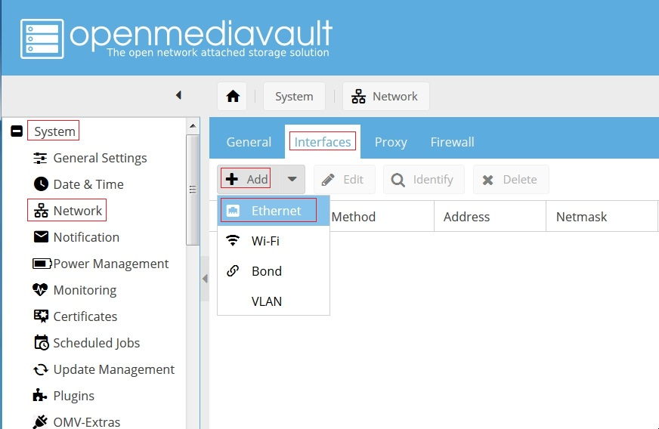

(Continued)
The following dialog box will popup:
Under General Settings:
- In the Name drop down, select the wired Ethernet interface. In this example there is one choice, eth0.
- In the Method drop down, select DHCP.

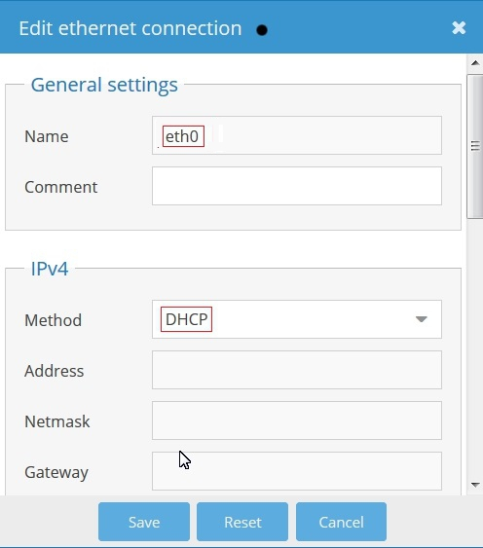
Click on Save, and confirm the change when the yellow confirmation banner pops up with “Apply”. Allow the “Apply configuration changes” dialog box to close.

Finishing Up:
New users can continue the Setup of OMV using this Guide, starting in the section titled OMV - Initial Configuration. Network settings, and other settings made as part of this installation, should be skipped.
All users are encouraged to review the section titled Operating System Backup for an easy process to clone your Raspberry PI's SD-Card.

